Notes from the
GNA-G Community VCs
Q3 2020
(version 0.9 - DRAFT)

These are the notes from the Global Network Advancement Group (GNA-G) Community VCs Q3 2020 that took place on Monday, 14 September 2020 2pm – 4pm UTC and on Tuesday, 15 September 2020 7am – 9am UTC, using Zoom.

Number of participants in the Zoom calls:
VC #1: 64 participants
VC #2: 47 participants

Agenda and links to the pre-recorded updates from the Working Groups can be found at:
https://www.gna-g.net/attend-a-meeting/gna-community-vcs-2020q3/

1. Opening & Welcome – Gerben 5’

Gerben welcomed all. He introduced the agenda for the meeting, and explained that the updates from the existing Working Groups were done through a pre-recording, to safe time in this 2-hour VC for interaction and discussions.

2. Setting the scene by Jim Ghadbane (President and CEO, CANARIE) 10’

GNA-G, the Global (R&E) Network Advancement Group, was created with the merger of the GNA Technical WG and GLIF, in 2019. Jim Ghadbane, President and CEO at CANARIE, and former co-chair of GLIF, has the inaugural role as Executive Liaison for GNA-G.

After the merger, there was a need for a link to the global NREN executives: A Liaising role. Jim agreed to take this role. He can be asked by the LT to deal with matters that need the attention of NREN CEOs.

Jim elaborated on a number of trends:
- We see much more invasive cloud adoption. Not only for research, but also for education. Lots of science moving to the cloud. The reliance on cloud services is sky-rocketing. What does that mean for GNA-G, as clouds become mission critical? Education cannot just rely on a best effort network. How does the GREN support that?
- Cyber Security, in two dimensions:
- We are here to serve the community Jisc, AARNet, and many other are starting to deliver security services.
- The GREN as the most cybersecure network available to our constituencies. MANRS falls in this category.
- Data management. The paradigm for research is shifting from access to a big science instrument to RDA standards to access data sets wherever they are. Traffic patterns are changing because of this. Moreover, the emergence of multi-disciplinary research. This means that as a researcher you need to have access to multiple data sets from all over the world.
- Where can the network technology take us? This is intrinsic to the role of the GNA-G. Where is the future of the network going? This does not come from the CEOs. Where do we need to be five years from now? The GNA-G can and should lead. Every now and then, we ask for volunteers. But this is or should be part of your job. Talk to your boss.

Chris Hancock (CEO, AARNet) added to this by stating that NRENs are pervasive and security is paramount, e.g. for medical research. The Global Research & Education Network, and hence the GNA-G, is more important to the world than ever, shown by the pandemic. We want the things that the GNA-G Participants come up with, as in general innovation is stalled around the world.

3. Updates from the GNA-G Leadership Team – Gerben 15’

Gerben presented a number of updates from the GNA-G Leadership Team using slides:
https://nordunet.box.com/s/kvjuqr3z4nwf4jtfevrrw1eeqe02ehbh

Questions & Discussion (Live and Chat), updates from the GNA-G Community:

- Jennifer Schopf: Will there be charters written for the existing working groups? Answer Gerben: Yes, the Leadership Team is working with the Working Group co-chairs to get them approved.

- Jennifer Schopf: TransPAC and NEA3R will receive funding for prolonging the connectivity between the USA and the Asiapacific region and the USA and Europe. Tenders are now out. More information soon.

- Harvey Newman: CENIC is completing the upgrade their 400G.

- Lawrence Wong: SingAREN is retendering 100Gs on Singapore – Japan and Singapore – USA.

- Erik-Jan Bos: The retendering of the Northern ANA 100G link between Amsterdam and Montreal is almost done. Major takeaway is that we are moving away from the retail market into the wholesale market, so towards an IRU.

- David Wilde & Steve Maddocks: AARNet is running the Sydney-Canberra production leg (286 kms) of our network on a 400G wavelength now. Between Sydney and Perth (wet part) and onwards to Singapore: 300G per wave.

- Last week Ciena released a new 800 Gb/s path in Canada: www.ciena.com/insights/articles/ciena-and-telus-bring-800g-to-canada-break-worldwide-transmission-record.html

- Rob Vietzke: Internet2 are deploying 400-800G line side waves. Still waiting on hardware and enabling software for client-side 400G.In July 2021, we expect our new 400G network to go live. Automation is high on the agenda. We have a new software team with five people assigned to this.

- Jan Ruzicka: We are upgrading to 400G now, also dealing with 400G worth of spectrum.

- Kevin Sale: KAUST closed the tender for 100Gs between Jeddah and Amsterdam and between Jeddah and Singapore. Planning: Production phase end of CY2020.

4. Network Automation – live presentation by Warrick Mitchell 20′

Warrick Mitchell introduced the Network Automation Working Group, that recently started, using slides:
https://nordunet.box.com/s/944d34xojhq2z66deiabncpiv9lar8nt

Important: Anyone who is putting up network infrastructure for R&E, and is interested in network automation, you are most welcome to participate. Please do contact Warrick Mitchell <Warrick.Mitchell@aarnet.edu.au> in case you want to participate.

Warrick mentioned that one of the first topics the Working Group is working on is a vocabulary, as he discovered that many people use a number of terms in different ways. Maria said that the work inside GÉANT has done an effort in this direction. Warrick will liaise with this work in GÉANT, to take this to a more global level.

Questions & Discussion (Live and Chat):

- Ivana Golub: In the GÉANT Project Work Package 6 we are working on similar things:
  - https://wiki.geant.org/display/OAV
  - https://wiki.geant.org/download/attachments/123792049/Orchestration%2C%20Automation%20and%20Virtualisation%20Terminology.pdf?version=1&modificationDate=1587389912527&api=v2

- Rob Vietzke: The Internet2 team is in the middle of this work as well, internal automation first, then stepping up towards APIs supporting external services (including cloud connect).

- Ivana: The next CI Eng Lunch & Learn talk will occur Friday Sept 18th @ 2pm ET. The speaker will be Edward Colone from The University of Michigan and he will be talking about “Provisioning perfSONAR with Ansible".

- Harvey Newman: If you want to integrate with science installations, the tools discussion is important. Three flavors to consider:
- A compelling tool, that everyone wants to adopt.
- Tool is already there, and you make an API.
- Tools have a different working context and to make them work together, you create an abstraction layer.

- Maria Isabel: You can also find some examples here: https://wiki.geant.org/display/OAV/OAV+COMMUNITY+PORTAL

5. Theme discussion 40’
a) How can we best support commercial cloud access (network aspects) – David 20’

David introduced the topic using slides:
https://nordunet.box.com/s/atmpum8dua5lte3vmfa583zl4ayp091w

David elaborated on the fact that many of us are working with cloud providers. Aims include getting a better deal, traffic discounts, and federated login. But we should realize that as one NREN, we are a drop in the water.

David ran the first poll (results from both Community VCs combined):

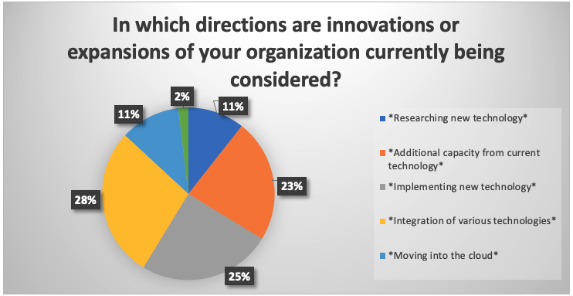

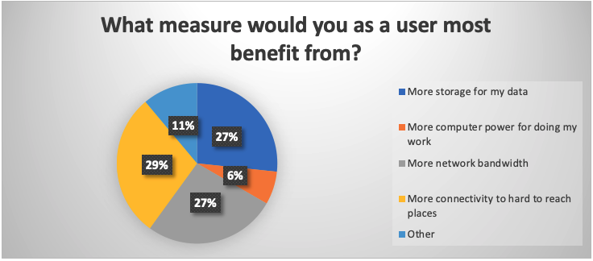

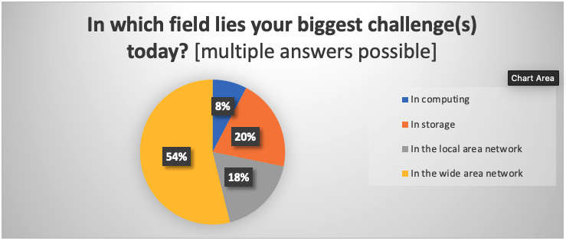

David: We think there is a set of services we can deliver better, more tailored for our community, and better integrated with other services we deliver. Also, commercial cloud providers need to make a profit. We deliver tailored, and not for profit. We are not competing with AWS.

Are cloud providers a threat or an opportunity for the NRENs?

- Lars: Some things we do are not too attractive anymore for our long tail. The commercial cloud providers have a slick packaging. There is the risk that they will go away, as it easier for them to just go to a commercial cloud provider for their job. We need to think how to offer services, also for the long tail.

- Eli Dart: If dedicated R&E resources would go, I think the compute centers would go first, if this would happen. For the network: We are determining the topology, as we know where the data streams are.

- Mark Wolff: 5G is also real estate play, for the antennas. No one player is going to dominate the market. It is not a threat; but we will have to work with them. I think that campuses should be investing in 5G towers, to allow for interoperability. Do not become a testbed for one vendor. The cost will be too high to move to another. Same for cloud: We have to work with cloud compute solutions, as well.

- Harvey Newman: This comes back to the budget. Applications that are compute intensive, and do not move a lot of data. For storage there is no comparison. The cost for storage is way too high with the cloud providers. Networking, getting your data out, is still also very high cost. The question is: Can we change their business models? So far this is not happening.

- David Wilde: At AARNet, we are developing a SOC. This involves a lot of storage and processing. We are running this on AWS today, and we are going to run this on-prem. Otherwise, way too expensive.

David concluded that it is important for the NRENs that we need to address the long tail as well. Eli added that especially the socio-political angle is important.

b) Understanding demands from advanced science & research – Buseung 20’

Buseung introducing the discussion on the demands from advanced science and research, using slides:
https://nordunet.box.com/s/e6ydxdy1qn5o69tfep9f2kprig0fzqrr

Poll

Next, Buseung opened the floor for questions and discussion.

- Carina Kemp: I see the challenge is over the top services to help researchers with their research data movement, orchestration and general management.

- Jennifer Schopf: Wearing my Engagement Center hat, we talk to researchers on campuses, across fields, and the biggest need they communicate to us is storage. We also help people with end-to-end transfer problems. Most of the time, the problem is within the campus. The big thing we see between institutions is routing error, such as weird asymmetric paths, preference of commercial networks over R&E networks, etc., that need attention.

- Mark Wolf: There are also advanced services from the Cloud Providers, such as services in data analyses and deep learning. This is “services on top” what they provide and that we provide access to. These are useful for our users, and I do not see us developing similar services.

- Eli Dart: Storage is going to be a significant limiting factor for everyone until we get disruptive technology to change that.

- Karina: I think researchers need integration of storage, compute and the network. And data orchestration

- David: Data movement service for researchers. Globus and Espira (sp?). Others do that?

- Steve M.: Instead of moving a file from A to B, accessing the data over the network, especially where the latency is a killer, is another approach. Is file system efficiency a research topic? Buseung replied that DTNs are here to help.

6. Active discussion on the pre-recordings 25’

a) GÉANT: architectures for NREN networks using TMF’s ODA – Maria Isabel Gandia, Sonja Filiposka 5’

Video: Orchestration, Automation and Virtualisation (OAV) in GÉANT – Maria Isabel Gandia, Sonja Filiposka 19′

Maria elaborated on the fact that the WG has been working on terminology and architecture, and now mapping this to the TMF-ODA framework. We are mapping to interdomain as well. Main goal is a common ground for the NRENs. Knowledge is important now. Some NRENs are active in this area. Some NRENs are too busy.

Maria asked the group if people have worked on integrated OSS and BSS, and if people are working on integration?

- Mian: GÉANT is working on a golden config automation solution.

- Rob: We do strive to automate the whole workflow. GlobalNOC tools do a lot of that and we will try to continue that as we move to new automation tools.

- Henrik: We are doing automation in both the network and in-service provisioning

- Ivana: From the survey we got back that we should not create something very specific, product oriented. As the European NRENs say: We are already running stuff and we will not switch to your newly developed product.

b) GREN Map WG – Ryan Davies 5’

Video: Update from the GREN Map Working Group – Ryan Davies 9′

Ryan quickly recapped the purpose of the GREN Map WG, by stating that the aim is to have a data architecture for storing network topology information, that enables map creation on many different abstraction levels. And he asked about comments and questions.

- Gerben: Should we go beyond plotting the maps? E.g., science instruments. Jennifer replied that IA created a science registry. Ryan replied that he is happy to talk further and look at integration.

- Lars: If you have the data, the meta data will be really helpful. And then we need to think about security concerns and privacy concerns. Ryan answered that security is surely on the minds of the WG. We are going through the recommendations, so everyone who shares their data can make good decision.

- Henrik: Do you do metrics integration? Ryan answered that this is not the perspective.

c) AutoGOLE/SENSE WG – Gerben van Malenstein 5’

Video: Update from the AutoGOLE/SENSE Working Group – Gerben van Malenstein 7′

Gerben asked the community that this WG is now going beyond the network; is this the right direction?

Some discussion about overlap with other groups, both inside and outside the GNA-G, such as the DIS WG and GREG. Gerben said that he is very aware of this, and that he considers this an opportunity for working together.

d) Offshore Students WG – David Wilde 5’

Video: Update from the Connecting Offshore Students Working Group – David Wilde 9′

David introduced the work of this WG by saying that for Australia, as an example, due to the pandemic and the lockdowns, 100,000 to 150,000 students from China could not come back anymore to their university in Australia. This WG is working on improving access to university resources for students at home. If you have similar issues with students, reach out to the WG and do contact David.

e) Data Intensive Science WG – Harvey Newman 5’

Video: Update from the Data Intensive Science Working Group – Harvey Newman 40′

Harvey introduced the topic using slides: https://nordunet.box.com/s/khie5bnkqkv4ejo0zwb5m29f3d6v161b

7. Announcement of next VCs and closure – Gerben 5’

Gerben thanked all participants for their active participation in the VC. A special thanks from the Leadership Team, on behalf of the GNA-G Community, goes to Maria, Sonja, and Ryan for pre-recording their Working Group updates.

Before Gerben closed the VCs, he ran an “exit poll”. The results, combined for both VCs, are as follows:

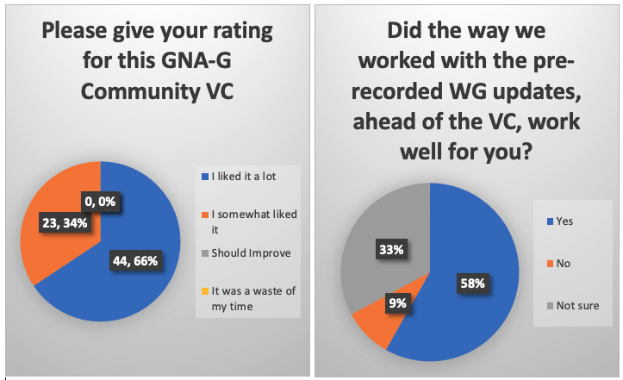

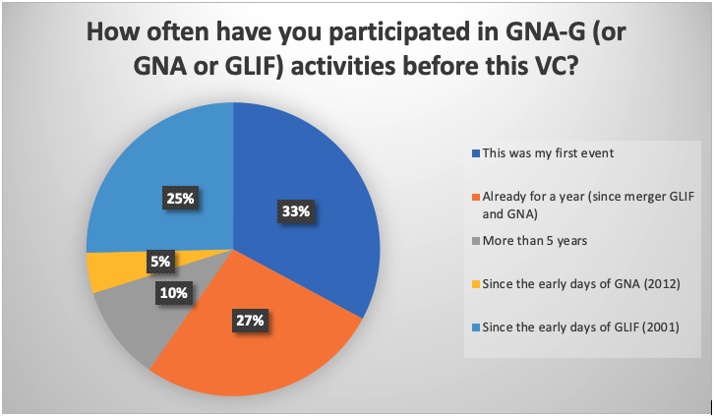

The next GNA-G Community VCs are scheduled to take place on:
- 7 December 2020 from 3pm to 5pm UTC
- 8 December 2020 from 8am – 10am UTC
An announcement will go out, closer to these dates.

# # # # #

