ESS Network, Copenhagen and Lund
This document outlines a proposal for network connections for ESS in Copenhagen and Lund, prepared jointly by SUNET, DeIC, and NORDUnet.

Requirements
ESS has two main sites: the accelerator site near Lund, Sweden, and the Data Management & Software Centre, Copenhagen. The requirement is for
- Internet uplink, with emphasis on connectivity to research and education users.
- Inter-site link, engineered so that ESS may treat both sites as a single production network
Reliability is essential, in particular for the inter-site link. For this reason, dual, resilient connections at both sites are required.
ESS has outline a traffic projection for both inter-site link and internet connection. In both cases, the projection is that traffic will ramp up slowly starting from 2020, reaching 8-9 Gbps on both connections (i.e., an aggregate of 17 Gbps) by 2026.
The ESS network requirements document notes especially that
- “In the early years of ESS the data volumes and rates are lower (fewer instruments and lower accelerator power) and easily satisfied by 10 Gbit/s connections. The experience that will be gained in those early years of ESS operation will allow much better estimates of data volumes and data rates to be made”, and
- “the prudent course is to implement now solutions for the DMSC network connections and data storage that are consistent [the projection] but which are scalable and can be expanded in the 2023 –2025 era if early results indicate that this is necessary”, and
- “While network data rates are important what is also equally important to ESS, especially for the connection between ESS in Lund and DMSC in Copenhagen, is reliability and robustness. Since this connection is, in many respects, a piece of the ESS instrument “hardware” it must be available “all” of the time that the ESS instruments are operating”
The proposal below has been prepared with the above in mind.

Assumptions
For the proposal, we have made a couple of assumptions
- The ideal internet uplink for ESS is a connection to a national research and education network (NREN), connecting ESS to the global R&E network infrastructure, as the majority of off-site users will be connected to a NREN network.
- A 10Gbps, resilient connection is today standard for (Nordic) NRENs. Both DeIC (Denmark) and SUNET (Sweden) can offer this for the ESS sites.
- The requirements for a resilient, 10Gbps inter-site link can be met with standard NREN products, delivering L2VPN connectivity with full resilient and 10Gbps capacity over a 100Gbps backbone.
- It is in the interest of ESS to use standard NREN services as much as possible, as this will keep cost down and ensure long-term stability.
- ESS is best served with a managed router and link solution, where NORDUnet takes responsibility for site routers for both uplink and inter-site link, and where routers are provided as part of the connectivity package. This ensures stability and long-term economy in case of upgrades.
Hence, we are proposing a solution based on 10Gbps uplinks, with full 10Gbps inter-site connectivity delivered using L2VPN products already available on NORDUnet and the Nordic NRENs. We realise that this is different than the potential 100Gbps inter-site link discussed at the 1 November meeting. However, given the traffic projections, we do not see a cost-benefit justification for such a solution, both in terms of equipment cost and engineering complexity.
We point out that the network connectivity solution proposed, based on L2VPN and 10Gbps connectivity, has been adopted by other demanding applications. For example, the network for the European HPC collaboration PRACE is being deploying using this product.
Furthermore, as the ESS traffic ramp-up is several years into the future, it is our firm belief that, should the capacity requirements exceed the projections, upgrading will not be a problem. By 2023, 100Gbps connections will be a standard product for both SUNET and DeIC, as will a 100Gbps inter-site link based on L2VPN. This is a good reason for ESS to adopt the managed router solution. Should an upgrade to 100Gbps be required in the future, ESS will not have to upgrade routers to accommodate the new requirements.

Design
The main features of the design are
- Dual, resilient 10Gbps links to each site
- Dual routers at each site
- Fully resilient MPLS-based links between the two sites, with full 10Gbps capacity on both links.
The logical network design is shown in the figure below.
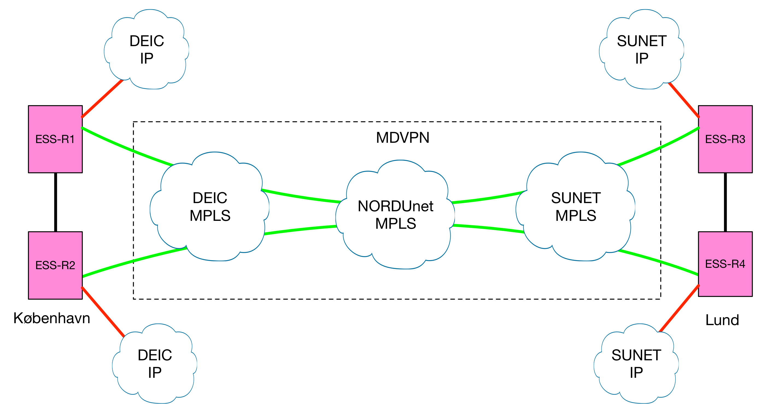
In this design, the inter-site link is based on an MD-VPN, an existing L2VPN product on DeIC, SUNET, and NORDUnet. MD-VPN provides all the resilience of the underlying MPLS networks. In this case, this means two, independent routes to both the Copenhagen and the Lund site, full resilience with at least two, independents connections between DeIC and NORDUnet and between SUNET and NORDUnet, and with at least two, independent connections between Denmark and Sweden.
In normal operation, traffic between the two sites will take a direct route from Lund to Copenhagen (using fibre on the Øresund bridge), with minimal latency. In an error situation, some additional latency will be added, but the L2VPN links will be transparently maintained.
In the initial configuration, each of the four uplinks will be 10Gbps, offering ESS a fully resilient day-one capacity of 10Gbps, shared between uplink and L2VPN. Once ESS traffic ramp up, this can be easily upgraded to 2x10Gbps or 100Gbps. Given the ESS traffic projections, we are confident that once the need for upgrade is there (by 2020 or later), the above design can be upgraded to 100Gbps with minimal impact on cost. As the routers in the design are part of the DeIC / SUNET delivery, an upgrade will be possible without expensive router upgrades for ESS.
It should be stressed that the above design ensures ESS full capacity and high performance and reliability between the sites, as a minimal additional cost compared to the cost of Internet / NREN connectivity for the sites.

Delivery
For simplicity, we propose three elements to the delivery, and hence three contractual relations:
- SUNET to deliver routers, IP uplink, MPLS L2VPN capacity
- DeIC to deliver routers, IP uplink, MPLS L2VPN capacity
- NORDUnet to deliver router management, inter-site link configuration, maintenance, monitoring
SUNET and DeIC will deliver full IP network service and access to the MPLS L2VPN services, in addition to the full range of NREN services such as eduroam, federated identity, etc. The DeIC* and SUNET delivery will include routers with appropriate interfaces, router hardware service and maintenance, and support. For more on the specifics on the DeIC and SUNET products, please consult the NRENs.
As an extension to the DeIC and SUNET service, NORDUnet will deliver the following
- Configuration and service management for the inter-site links
- Router and routing management for both sides, ensure optimal site connectivity
- Full 24/7 NOC availability
- A 10Gbps monitoring node at each site, with a web-based portal for regular and ad-hoc latency and capacity tests between sites as well as between ESS and sites on the NORDUnet network.
In this way, ESS is ensured professional management of the router and inter-site link setup, with a single entity taking end-to-end responsibility, and will have documentation for inter-site performance.

Cost
The cost for connectivity to ESS Lund (SUNET) and ESS Copenhagen (DeIC) should be agreed directly with the NRENs. Both DeIC and SUNET have standard pricing models, nationally agreed for the R&E sector.
The additional cost for the NORDUnet L2VPN service management, router management, and 24/7 support is 6200 € / year.

* It should be noted the DeIC has a basic connectivity product, and a product that includes on-site routers. We are here assuming the latter, slightly more expensive product, as the routers are needed to deliver management of the L2VPN service.

